ISO 27017 Compliance for Log360
Strengthen cybersecurity and meet ISO 27017 compliance with Log360.
Region: International | Type: Industry Standard | Category: Compliance | Pricing: Free

Overview
The ISO 27017 compliance extension in Log360 helps organizations meet ISO/IEC 27017:2015, the cloud security standard published by ISO/IEC providing additional implementation guidance for 37 ISO 27002 controls and 7 cloud-specific controls governing shared responsibilities in cloud environments by providing centralized log management, cloud activity monitoring, and cloud-focused compliance reporting. The platform supports ISO 27017 requirements for cloud access control, identity and privilege management, configuration management, network security, data activity monitoring, incident detection, audit logging, shared responsibility governance, and virtual infrastructure security across cloud environments.
For Cloud Access Control & Authentication, Log360 monitors AD logon reports, Entra ID user logon events, MFA authentication activity, risky sign-in detections, and cloud user login records to detect unauthorized cloud access. To address Cloud Identity & Privileged Access Management, the platform monitors Entra ID role management, user management events, group membership changes, directory management, and AD OU delegation to detect unauthorized cloud privilege assignments. The extension also supports Cloud Configuration & Asset Management by providing capabilities that monitors AWS Config reports, EC2 instance events, Entra ID device management, and cloud policy management to track cloud asset states and detect unauthorized configuration changes.

Key Features
- Cloud Network Security & Traffic Analysis: Log360 monitors AWS Network Security Groups, VPC activity, network device attack reports, security reports, and Windows firewall auditing to detect unauthorized cloud traffic.
- Cloud Storage & Data Activity Monitoring: Log360 monitors AWS S3 bucket activities, S3 file changes audit, SharePoint file activities, OneDrive file activities, and cloud storage security reports to protect cloud-stored data.
- Cloud Security Incident Detection & Response: Log360 monitors AWS failed and unauthorized activity, Exchange Defender alerts, Windows firewall threats, and network attack reports to detect cloud security incidents.
- Cloud Audit Logging & Monitoring: Log360 monitors AWS user activity, Salesforce setup audit trails, Entra ID directory management, cloud user login events, and EventLog reports to maintain comprehensive cloud audit trails.

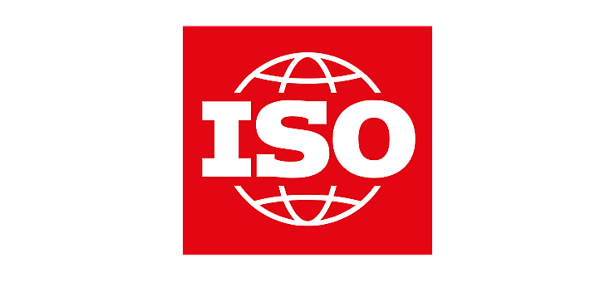
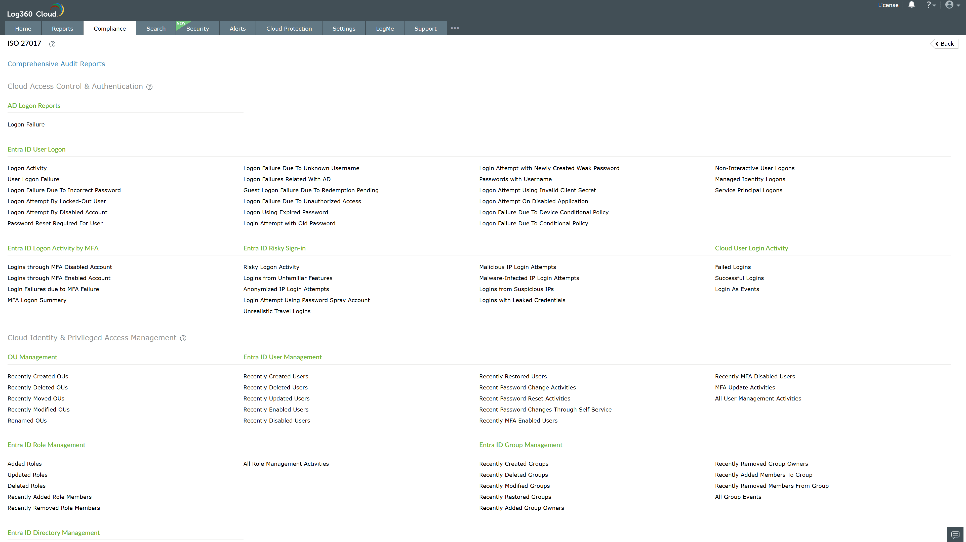
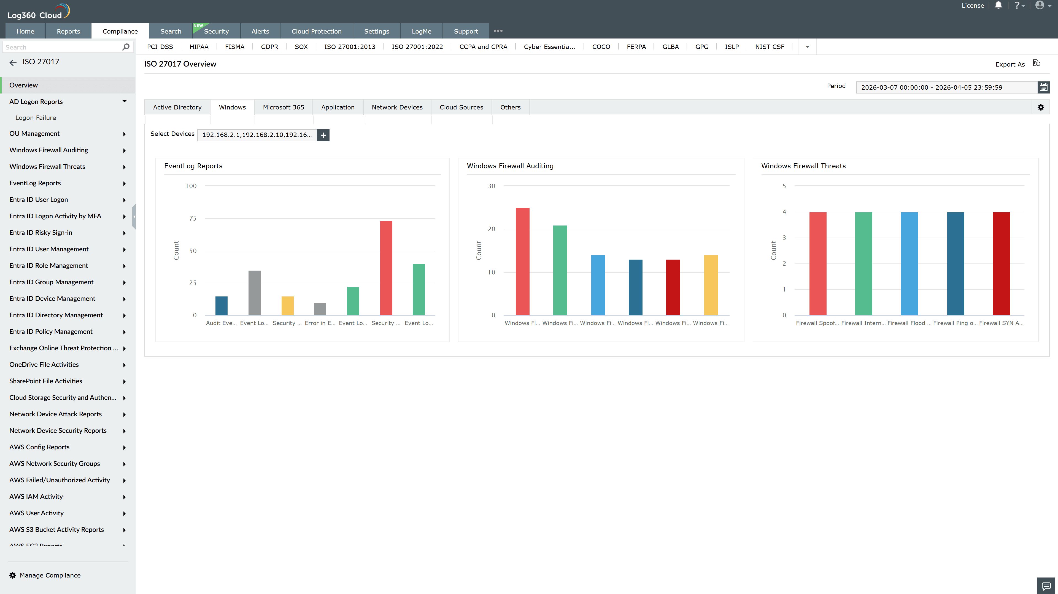
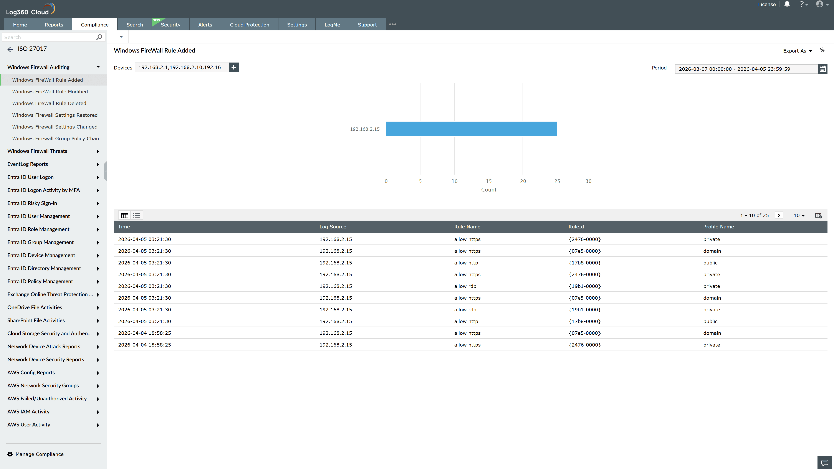
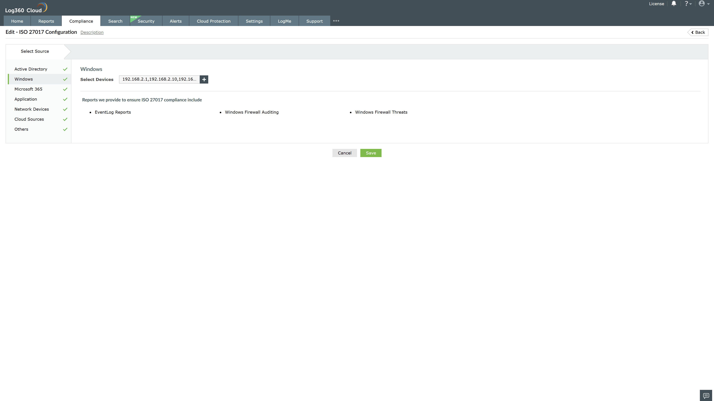
Valid Submission : Yes
Supported Editions : Free, Basic, Standard, Professional, MSSP
Help Document : https://www.manageengine.com/log-management/help/integrations/compliance-extensions.html
Help Video : Not provided
Tags : Log360, Compliance, Privacy monitoring, Data privacy, Regulatory compliance
Supported DCs : US, IN, JP, CA, AU, UK and EU
Privacy Policy:
Terms of Service:
Release Notes:
Predefined reports for the ISO 27017.

